Program: Microsoft Office PowerPoint
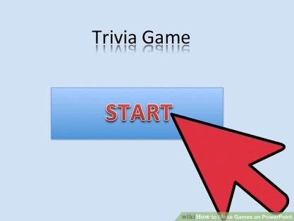
Directions: Create your very own game/trivia show on PowerPoint and test your game with the class.
F.1

Steps:
- Open PowerPoint & Add Title/Name & Start option (Slide 1).
- Add a new slide, and type a question (Slide 2).
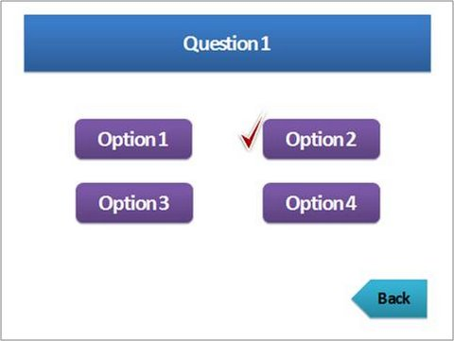
- Insert shapes & add text for answer choices (Slide 2).
F.2
- Insert a new slide & insert shape, add text, “Try Again!” (Slide 3).
- Insert a new slide & insert shape, add text, “Correct!” (Slide 4).
- Go back to slide 2, right click on shapes and insert hyperlinks
connecting slide 3 or 4 as your response.
- Repeat step 6 for all the options on question page (Slide 2).
F.3
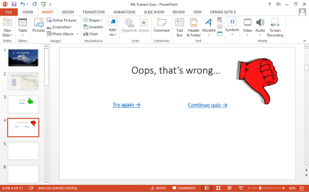
- Go back to Slide 3, insert a small shape, add text or symbol for
Going back to the question page, and right click to add
hyperlink connecting to slide 2.
- Go back to Slide 4, insert a small shape, add text or symbol to
continue game.
- Insert Slide # 5. Go back to Slide 4, and add hyperlink connecting
F.4
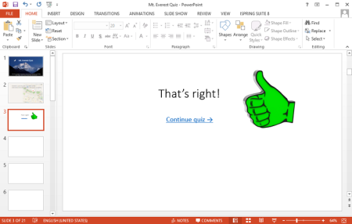
The small “Continue” shape to the next question page (Slide 5).

- To insert more questions, you may repeat steps 1-10, and also copy and paste Slides 3 & 4 for your “Correct” or “Incorrect” options (Don’t forget to edit hyperlinks!).
- Enjoy creating and presenting/hosting your trivia game show!

